**EKİM**

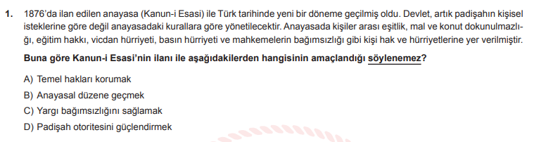

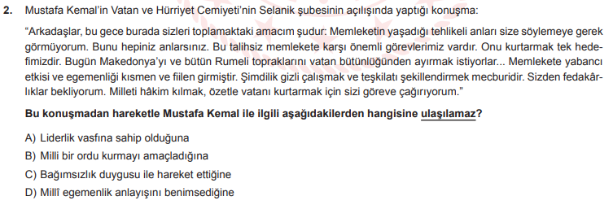

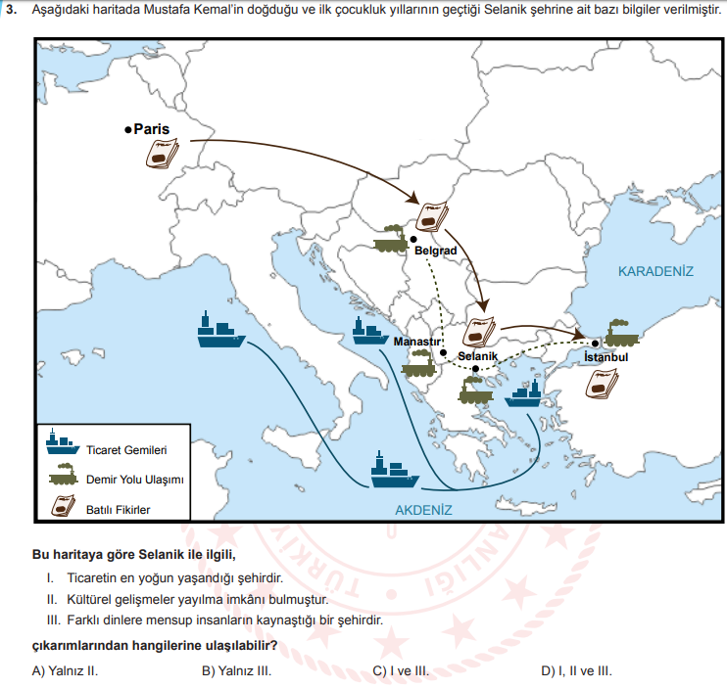

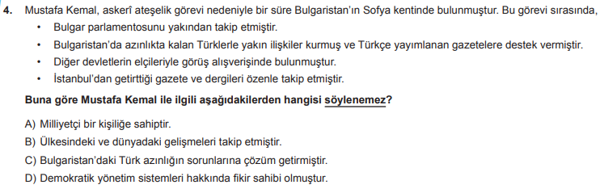

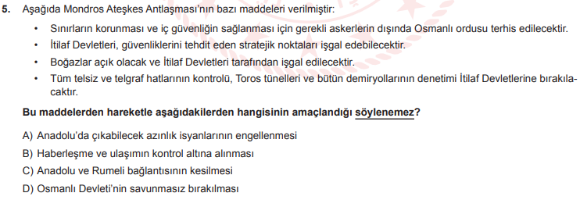

**KASIM**

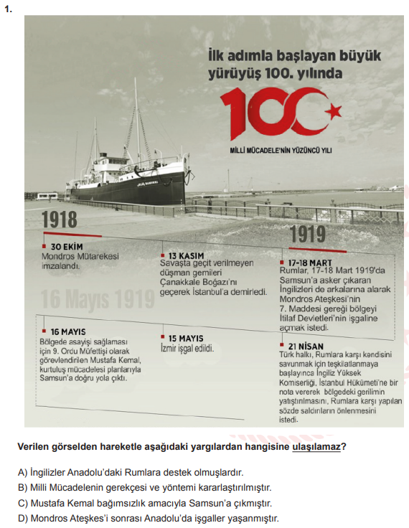

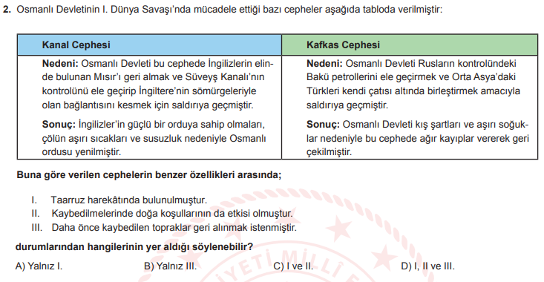

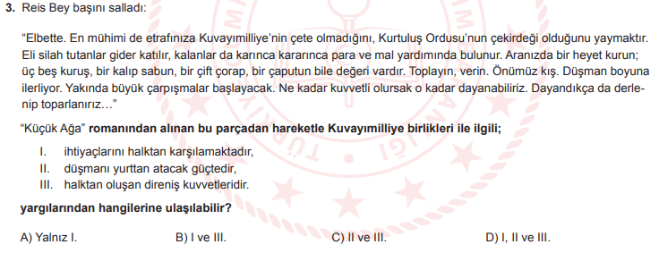

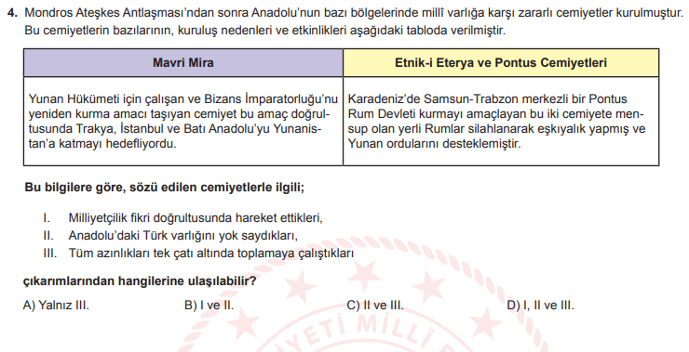

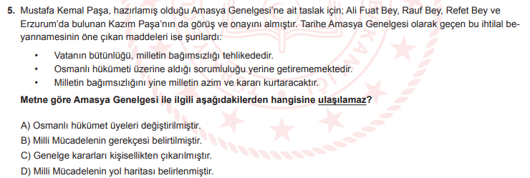

**ARALIK**

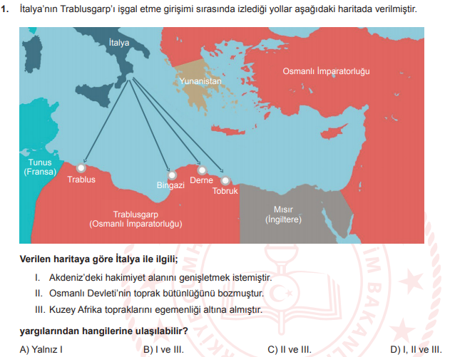

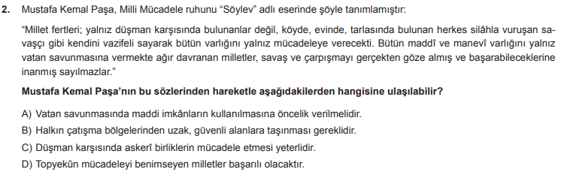

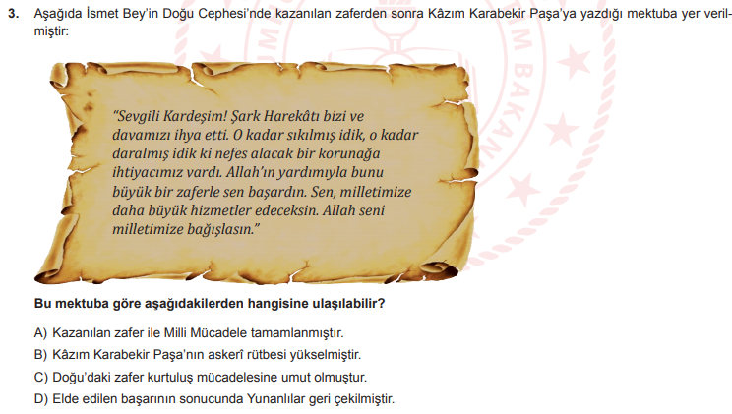

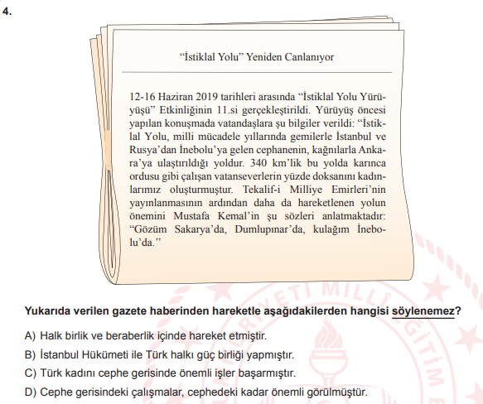

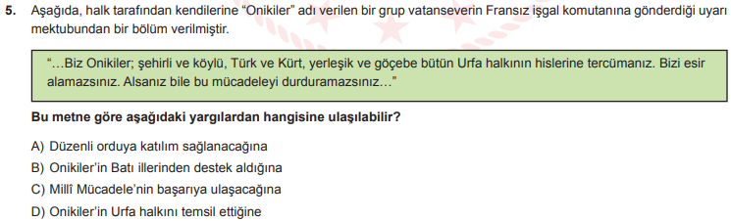

**OCAK**

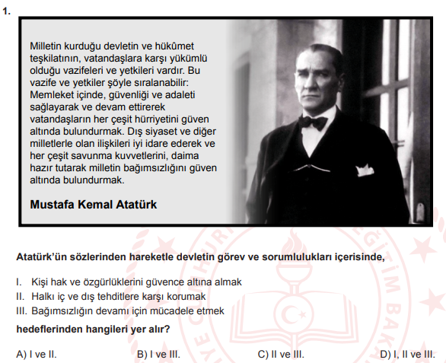

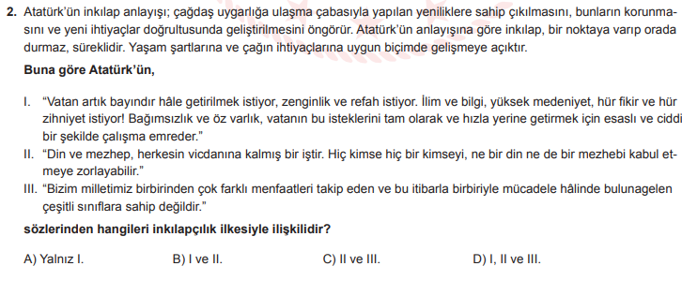

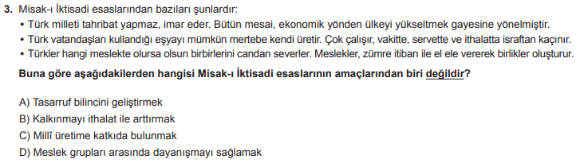

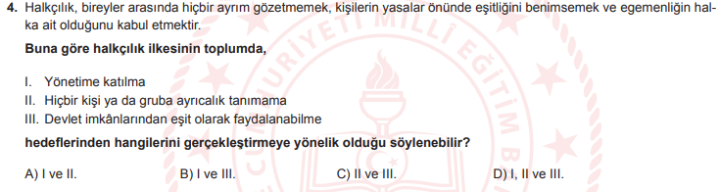

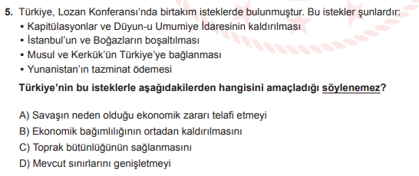

**ŞUBAT**

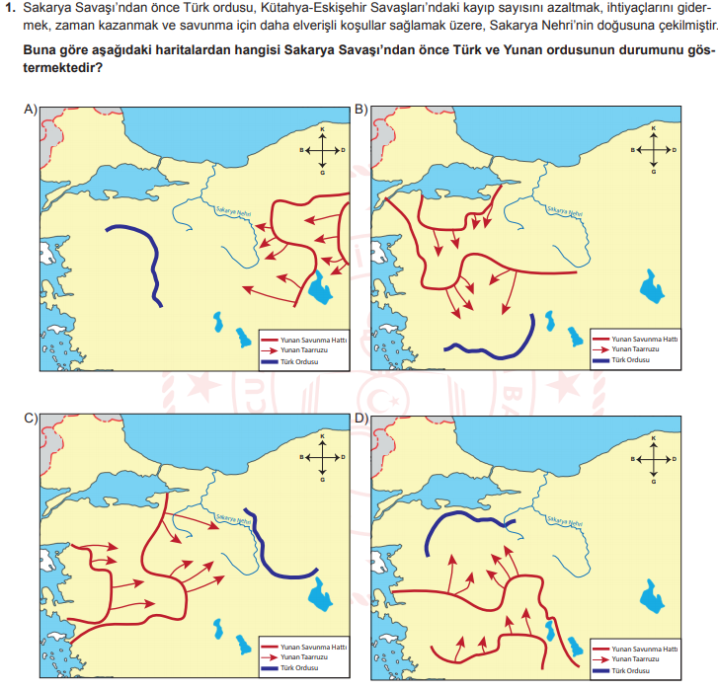

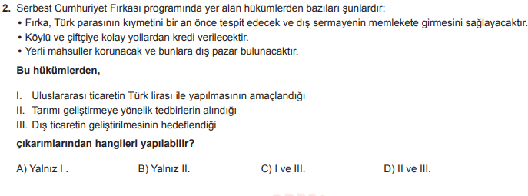

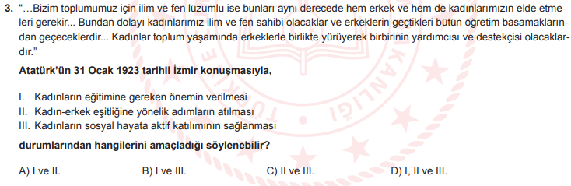

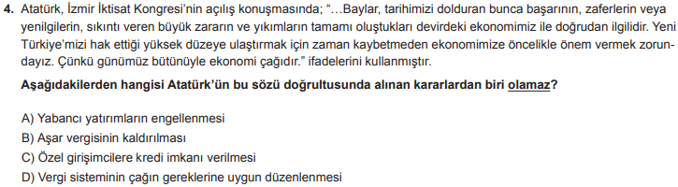

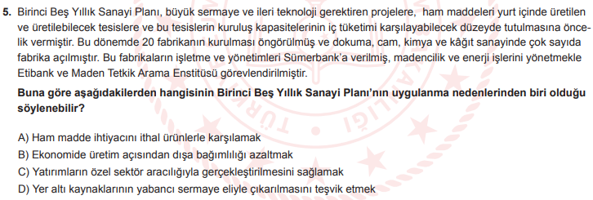

|  |  |  |  |  |
| --- | --- | --- | --- | --- |
| **EKİM** | **KASIM** | **ARALIK** | **OCAK** | **ŞUBAT** |
| **D** | **B** | **A** | **D** | **C** |
| **B** | **C** | **D** | **A** | **D** |
| **A** | **B** | **C** | **B** | **D** |
| **C** | **B** | **B** | **D** | **A** |
| **A** | **A** | **D** | **D** | **B** |